Tasks

1.Visit a local retail store or supermarket and observe any ongoing BTL (Below The Line) activations or product sampling activities; write a short report describing what you saw, including the product, the activation method, and how customers interacted with it.

2.Design a creative BTL activation plan to promote a new energy drink at a college festival; include the activity concept, required materials, and how you will encourage students to try the product.

3.Create a digital flyer (using Canva, Photoshop, or PowerPoint) for a product sampling event for a new snack brand at a popular hangout spot in your city, making sure to include date, location, and a catchy tagline.

4.Interview 3 friends or classmates about their experience with product sampling (such as free samples at malls, food courts, or events); summarize their feedback and list two ways the sampling could have been improved.<br><br><em><strong>Hint:</strong> Focus on what made them try (or not try) the sample and whether it influenced their purchase decision.</em>

Answer:-

1. Store BTL activation report
Store visited: [Reliance Fresh / D-Mart / Local Supermarket]
Location: [Apne area ka naam]
Date: [Date]
Maine supermarket ke food and beverages section ke paas ek product sampling activation dekha. Ek promoter ne new flavoured biscuit/snack/juice product ka branded counter lagaya hua tha. Counter par product packets, price offer board aur small disposable cups/plates rakhe the.

Activation details
- Product: New flavoured snack / fruit juice / biscuit
- Activation method: Free product sampling counter
- Offer shown: “Try Free” aur “Buy 2 Get 1 Free”
- Customer interaction: Promoter customers ko politely sample offer kar raha/rahi tha aur product ka flavour explain kar raha/rahi tha.
- Customer response: Bachche aur young customers sample try karne ke liye excited the. Kuch customers ne taste karne ke baad product packet trolley mein add kiya.
- Extra engagement: Promoter ne QR code scan karne par coupon ya discount offer bataya.

Short analysis
Yeh BTL activity effective thi because customer ko product kharidne se pehle taste karne ka chance mila. Free sample ke saath discount offer hone se purchase ka chance aur increase hua. Counter ko beverage/snack aisle ke paas rakhna bhi smart tha, kyunki interested customers product wahi se easily pick kar sakte the. Product sampling malls, supermarkets, campuses aur other high-footfall locations par direct trial aur customer interaction ke liye commonly used BTL format hai.

2. College-festival energy-drink BTL plan
Energy drink brand: VoltRush
Campaign name: “Charge Up Your Fest!”
Target audience: College students aged 17–25

Activity concept
Main college festival mein ek interactive VoltRush Energy Challenge Zone lagunga/lagungi. Students ko ek short fun challenge complete karna hoga—jaise reaction-time game, dance-off, gaming challenge ya 30-second rapid quiz. Challenge ke baad unhe chilled VoltRush ka free sample diya jayega.

How it will work
- Festival entrance ya main stage ke nearby VoltRush branded stall/canopy lagaya jayega.
- Students registration desk par apna naam aur Instagram handle enter karenge.
- Har student “30-Second Energy Challenge” play karega—fast tapping game, reaction-light game ya mini dance challenge.
- Challenge complete karne ke baad student ko free chilled VoltRush sample milega.
- Student selfie/photo booth mein picture lekar Instagram par #VoltRushFest tag karega.
- Best score aur most creative post ko prize milega—fest passes, merchandise ya hamper.
- Sample ke saath ₹20 off coupon diya jayega, jo college canteen ya nearby store par redeem ho sakega.

Required materials
- Branded canopy or stall
- VoltRush cans and disposable sample cups
- Ice box/refrigerator
- Branded standees, banners and LED lights
- Reaction-time game/tablet or laptop
- Photo booth with hashtag backdrop
- QR-code registration form
- Coupon cards
- Promoters and event volunteers
- Dustbin and hygiene supplies

Why students will try it
- Free chilled drink aur interactive game students ko stall tak laayega.
- Competition aur prizes excitement create karenge.
- Instagram photo booth social-media sharing ko encourage karega.
- Coupon ke through first paid purchase ka reason milega.
BTL activations ka goal sirf product dikhana nahi, balki target audience ko product try karwana aur direct brand experience dena hota hai. College, festival aur high-footfall event locations sampling-led engagement ke liye suitable hote hain.

3. Digital flyer for snack sampling
Snack brand: CrunchPop
Event name: CrunchPop Free Taste Fest
Hangout spot: [Popular café / mall food court / college canteen / city park name]
Date: Saturday, [Date]
Time: 4:00 PM–8:00 PM

Flyer

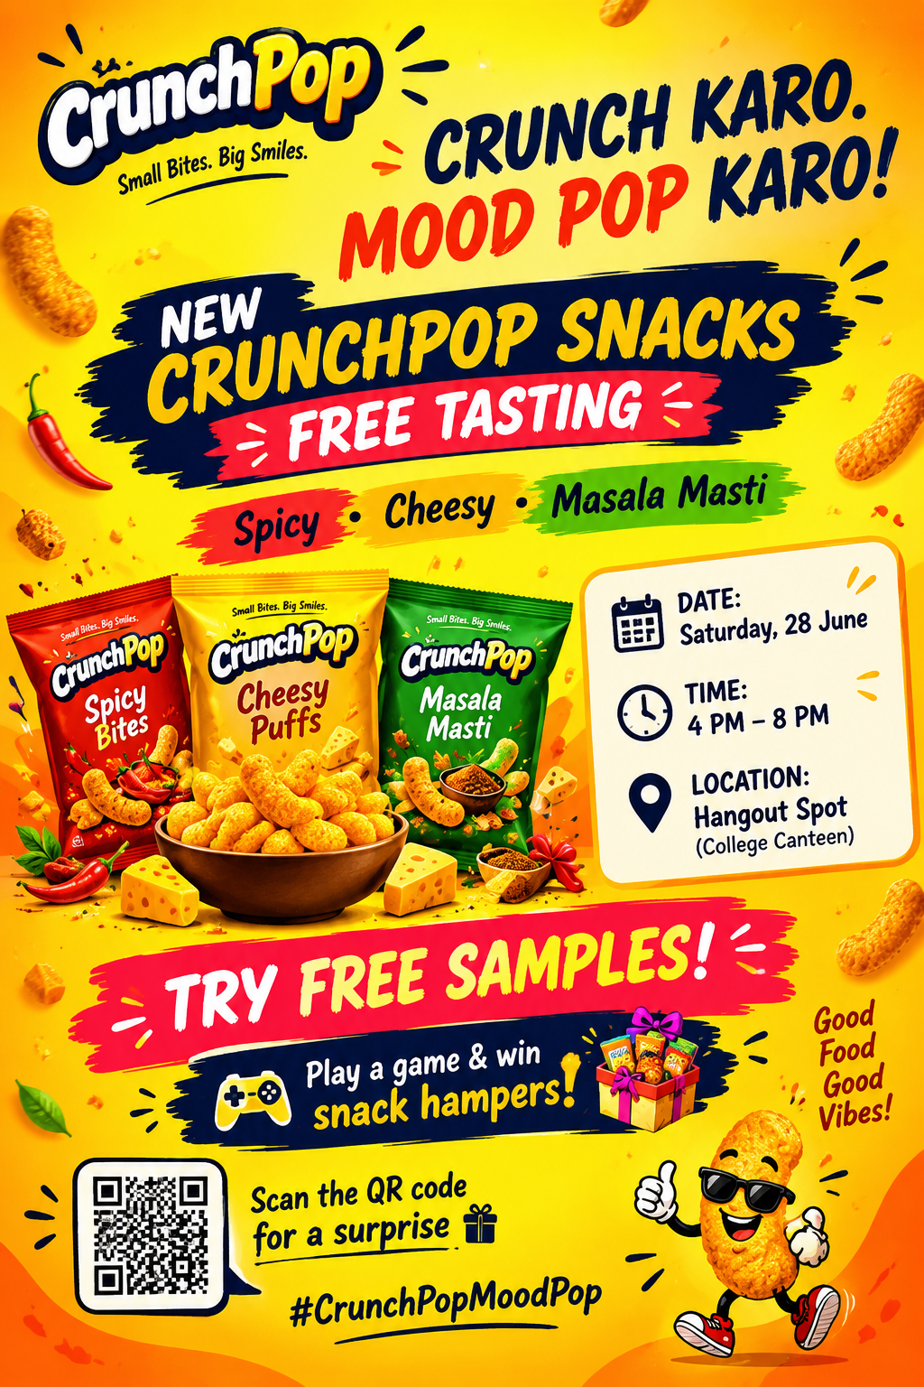

Flyer design idea
- Background: Bright yellow and orange, because yeh colours energy aur snack-category feel create karte hain.
- Visual: Centre mein open snack packet with chips flying out.
- Headline: Large bold font—“Crunch Karo. Mood Pop Karo!”
- CTA: “Try Free Samples!” ko red badge ya sticker shape mein dikhayenge.
- Extra: QR code add karenge for event registration, coupon or Instagram contest.
- Placement: Flyer ko café noticeboard, college gate, food court aur Instagram story format mein share kiya jayega.
Sampling event mein QR registration aur feedback form useful ho sakte hain, kyunki brand sample distribution, consumer interest aur later follow-up track kar sakta hai.aimnow+1

4. Product-sampling interview feedback
Note: Neeche sample interview summary hai. Actual submission mein aap apne 3 friends ke real answers likh sakte ho.
Person | Sampling experience | Sample try karne ka reason | Purchase decision

Person | Sampling experience | Sample try karne ka reason | Purchase decision
Friend 1: Ayaan | Mall mein free flavoured yoghurt sample try kiya. | Free tha aur promoter ne flavour interesting explain kiya. | Taste pasand aaya, isliye same day ek pack buy kiya.
Friend 2: Riya | Food court mein new chips ka sample mila. | Packet design colourful tha aur friend ne bhi try kiya. | Sample achha tha, but price thoda high laga, isliye buy nahi kiya.
Friend 3: Kabir | College event mein energy drink sample try kiya. | Free drink aur game competition ka attraction tha. | Drink refreshing laga, but sugar content/ingredients clear nahi the, so regular purchase decide nahi kiya.

Common feedback
- Free sample aur attractive counter logon ko product try karne ke liye motivate karte hain.
- Promoter ka friendly behaviour aur flavour/product explanation important tha.
- Discount coupon ya launch offer purchase decision ko stronger bana sakta hai.
- Price, ingredients aur product benefits clear na hon toh customers sample try karke bhi buy nahi karte.

Two improvements
- Clear information display: Sampling counter par price, ingredients, allergens, nutrition details aur offer clearly visible hone chahiye. Isse customers ko informed choice lene mein help milegi.
- Instant purchase incentive: Sample ke baad “Buy Now and Get 20% Off” coupon, combo offer ya small freebie diya jaana chahiye. Isse free trial actual purchase mein convert hone ke chances badhte hain.

